**IBM PROJECT**

SMART SOLUTION FOR RAILWAYS

**Batch:**B1-1M3E

**Team ID:**PNT2022TMID47478

**Team Leader:**MONISH KUMAR T S

**Team Members:**

❭ KOKILA N

❭ SUBA LAKSHMI P

❭ JAYA KUMARAN S

**CONTENTS**

|  |  |
| --- | --- |
| TITLE | **PAGE NUMBER** |
| 1. **INTRODUCTION** | 4 |
| a. Project Overview | 4 |
| b. Purpose | 4 |
| 2.  **LITERATURE SURVEY** | 4 |
| a. Existing problem | 4 |
| b. References | 4 |
| c. Problem Statement Definition | 5 |
| 3. **IDEATION & PROPOSED SOLUTION** | 5 |
| a. EmpathyMap Canvas | 5 |
| b. Ideation & Brainstorming | 6 |
| c. Proposed Solution | 8 |
| d. Problem Solution fit | 9 |
| 4.   **REQUIREMENľANALYSIS** | 10 |
| a. Functional Requirements | 10 |
| b. Non-Functional Requirements | 10 |
| 5.   **PROJECT DESIGN** | 11 |
| a. Data Flow Diagrams | 11 |
| b.   Solution & Technical Architecture | 11 |
| c. User Stories | 12 |
| 6.   **PROJECľPLANNING & SCHEDULING** | 13 |
| a. Sprint Planning &Estimation | 13 |
| b. Sprint Delivery Schedule | 13 |
| c. Reports from JIRA | 13 |

|  |  |
| --- | --- |
| 7. **CODING & SOLUTIONING** | 14 |
| a. Feature 1 | 14 |
| b. Feature 2 | 15 |
| 8. **TESTING** | 15 |
| a.   Test Cases | 15 |
| b.   UserAcceptance Testing | 15 |
| 9. **RESULTS** | 15 |
| a. Performance mertices | 15 |
| 10. **ADVANTAGES & DISADVANTAGES** | 16 |
| 11. **CONCLUSION** | 16 |
| 12. **FUTURE SCOPE** | 17 |
| 13. **APPENDIX** | 17 |
| Source Code | 17 |
| GitHub &Project Demo Link | 17 |

**1.INTRODUCTION**

        **1.1 Project Overview**

A Web page is designed for the public where they can book tickets by seeing the available seats.After booking the train, the person will get a QR code which has to be shown to the Ticket Collector while boarding the train.The ticket collectors can scan the QR code to identify the personal details.

**1.2 Purpose**

Smart Solutions for railways is designed to reduced the work load of the user and also the use of paper.

**2. LITERATURE SURVEY**

**2.1 Existing Problem:**

In their busy schedule as fast roaming world public in need of online booking process. The queues in front of the ticket counters in railway stations have been drastically increased over the period of time.

* 1. **References:**

OSIRIS, “Smart grid system definition, system studies and modeling, technologies evaluation”, Deliverable 4.1., 2013 ,D. CORNIC, “Efficient recovery of braking energy through a reversible dc substation”, Alstom Transport, IEEE, Electrical Systems for Aircraft, Railway and Ship Propulsion (ESARS), 2010 ,Ch. Barjracharya, “Control of VSC-HVDC for wind power”, Master of Science in Energy and Environment Report, June 2008, Abhishek Ghosh, Indiabar Sengupta, Soumik Sen, Subhashis Maitra, “An Automatic Integral Safety System for Railways (With Inbuild Capability Of Colission Avoidance & Solving Problem Of Unmanned Level Crossing)”, International Journal on Recent Trends in Engineering and Technology, Volume 6, Number 2, November 2011. , Aditya Kakde, Ashish Ramteke, Swapnil deotale, Irshad quereshi, Prof.H.M.Raza, “Railway Tracking and Gate Control System by Using Android App and Wi-Fi Module”, International Journal of Engineering Science and Computing, April 2016, R.Karthik, Aby.K.Thomas, “Automated Train Control System with Real Time Train Tracking Facility Based On GPS and Onboard Disaster Prevention Network”, Volume 3 Issue 4, April 2014.

**2.3 Problem statement definition:**

Ticket reservation through counter is not sufficient and convenient for the passengers. The passengers are struggling to get tickets in the time from ticket counters. So they like to switch over online ticket booking.

**3. IDEATION & PROPOSED SOLUTION**

**3.1 Empathy Map Canvas:**

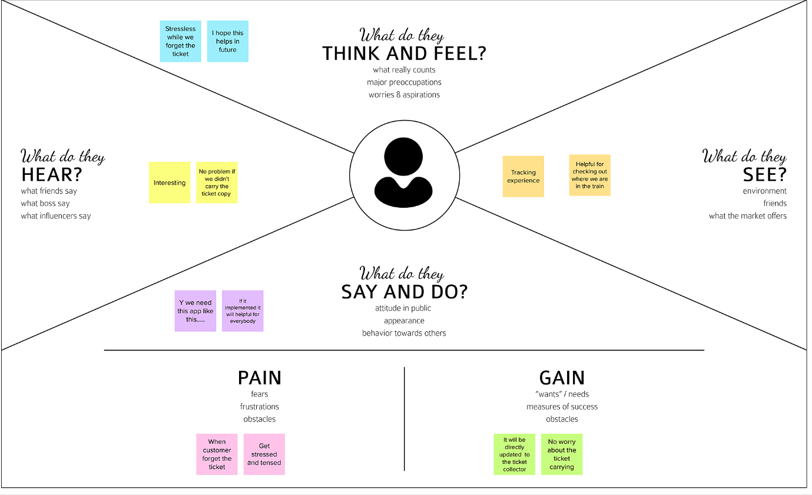

**3.2 Ideation & Brainstorming:**

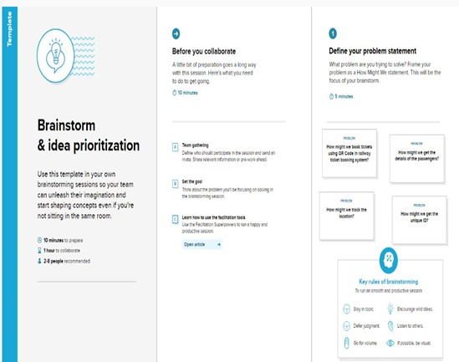

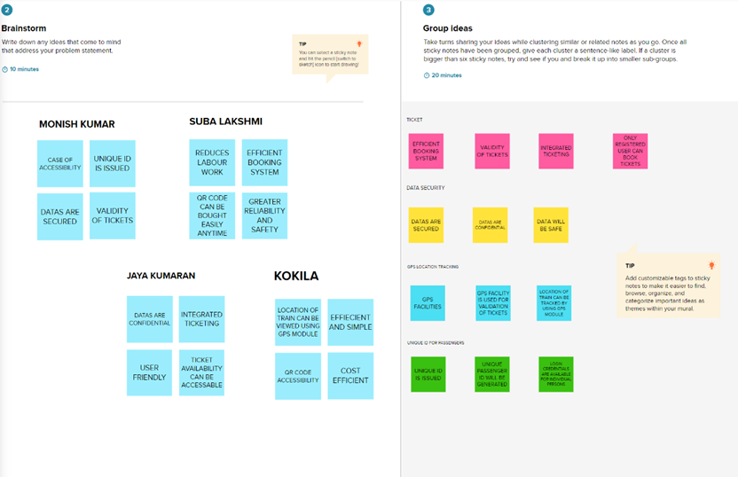

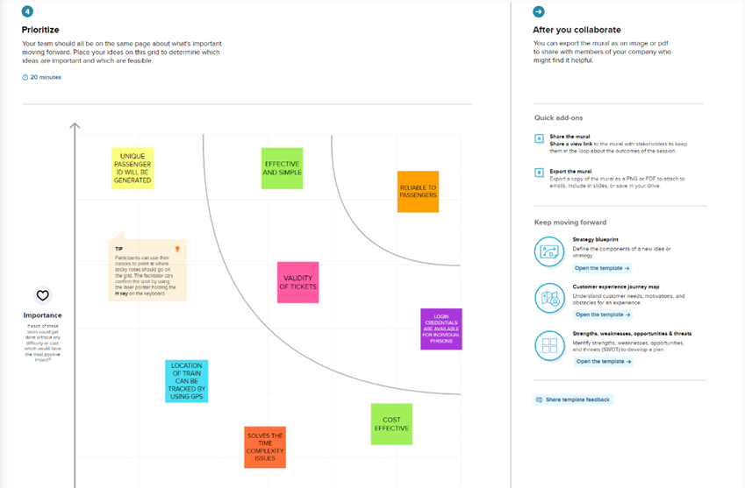

**3.3 Proposed Solution:**

|  |  |  |
| --- | --- | --- |
| **S.No.** | **Parameter** | **Description** |
|  | **Problem Statement (Problem to be solved)** | *Smart Solutions for railways is designed to reduced the work load of the user and also the use of paper and also provides the live location of the train.  *In their busy schedule as fast roaming world public in need of online booking process. The queues in front of the ticket counters in railway stations have been drastically increased over the period of time.  *Ticket reservation through counter is not sufficient and convenient for the passengers. The passengers are  struggling to get tickets in the time from ticket counters. So they like to switch over online ticket booking. |
|  | **Idea / Solution description** | *A webpage is designed in which the user can book tickets and will be provided with a QR code which will be shown to the ticket collector and the ticket  collector will be scanning  the QR code to get the passenger details.  * The webpage also shows the live locations of the train by placing a GPS module in the train. The location of the journey will be updated continuously in the webpage.  * The booking details of the user will be stored in the database which can be retrieved anytime. |
|  | **Novelty / Uniqueness** | *A QR code will be provided by the webpage to the user which will reduce the paper work.  *All the booking details of the customers will be stored in the database with a unique ID and they can be retrieved back when the Ticket Collector scans the QR Code.You can also view interactive seat map. |
|  | **Social Impact / Customer Satisfaction** | *The booking  tickets is made easy to use and it is also reliable and no need to go to station for booking tickets and the transaction process is also made easy.  *One can manage online ticket booking and apply for a  cancellation in case of any change in plans .  *the customer will be notified on email as well as cell phone on all confirmation and cancellations. |
|  | **Business Model (Revenue Model)** | *with this solution - By using this application, the customer can schedule their destination, view availability of the seat, view interactive seat map and select their seat for their convenience. Moreover, it enables your customers to organize trips and daily shuttles effortlessly and it also reduces the carrying of tickets. The customer can also watch the current location of the train.  *without this solution – they have to travel to the station to book tickets and also have to carry their tickets to show to ticket collector. |
|  | **Scalability of the Solution** | 1. No need of taking print out. 2. Counter ticket has to be handled with care, but SMS on mobile is more than enough. 3. You are becoming environment friendly and contributing for greener planet by ignoring printout. 4. No need of taking out wallet and showing your ticket to TTR, just tell your name to TTR that you are passenger with a valid proof. 5. While booking counter ticket you had to carry cash and while booking E- ticket you are paying through online directly from bank which makes work more easy for you. |

**3.4 Problem Solution Fit:**

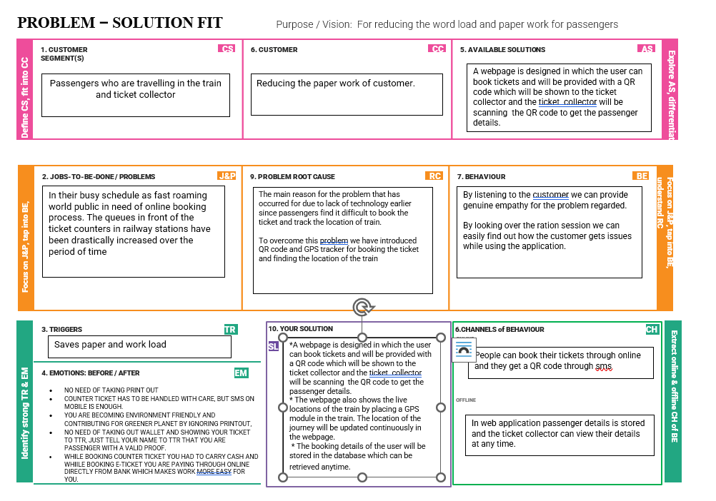

**4. REQUIREMENT ANALYSIS:**

**4.1Functional Requirements:**

Following are the functional requirements of the proposed solution.

|  |  |  |
| --- | --- | --- |
| **FR No.** | **Functional Requirement (Epic)** | **Sub Requirement (Story / Sub-Task)** |
| FR-1 | User Registration | Before the user registration there will be language selector .All the language is applicable.When user enter in to the application they can see the page of showing  enter the email ,mobile number and name.After that in screen it shows the verification code is sended through the email id. |
| FR-2 | User verification | The verification code is sended to the registered email id |
| FR-3 | User confirmation | The verification code is entered in to the app application.After finishing that home page is opened. |
| FR-4 | Process of booking | When the home page is opened there will be a from and to option.We must enter the details then after that we can able to see the number of trains availability and seats availability.We can select the particular train and particular seats which we need and click the confirm option. |
| FR-5 | Payment process | After entering all the details  select the payment option like google pay,phone pay,pay tym,etc……..  When we select that method  it process through selected  payment option then payment should be done carefully,then the ticket is confirmed.After confirmation it will return to the page and we can see the details of booking. |
| FR-6 | Confirmation message | After all the QR code will be send through the sms and email id. QR code will be shown to  the ticket collector when the QR code is scanned  booking details will be shown . |

**4.2 Non-functional Requirements:**

Following are the non-functional requirements of the proposed solution.

|  |  |  |
| --- | --- | --- |
| **FR No.** | **Non-Functional Requirement** | **Description** |
| NFR-1 | **Usability** | The app is set to easily method only. All the languages will be accessed  through by user. |
| NFR-2 | **Security** | The permissions access is only for the location access only there will be no other  unauthorized permission should be entered to it. |
| NFR-3 | **Reliability** | When the user are entering the details,that time if network connection is disabled. All the details will be stored automatically. No need to enter the details again. |
| NFR-4 | **Performance** | The application is more secured and it will obtain through the back end . no unauthorized  can  access the application |
| NFR-5 | **Availability** | only the QR code is sended  through the message and email id only no other information is included |
| NFR-6 | **Scalability** | At a time more than 300,000 users  can obtain .All the data will be stored carefully and other issues will be obtain. |

**5. PROJECT DESIGN**

**5.1 Data Flow Diagrams:**

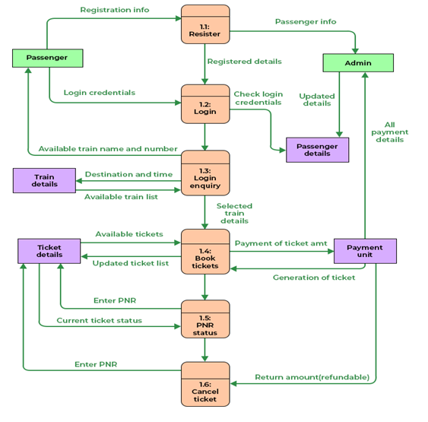

**5.2 Solution & Technical Architecture:**

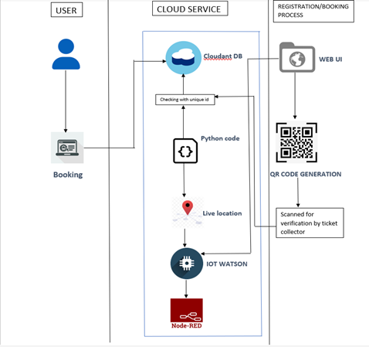

**5.3 User Stories:**

|  |  |  |  |  |  |  |
| --- | --- | --- | --- | --- | --- | --- |
| **User Type** | **Functional Requirement (Epic)** | **User Story Number** | **User Story / Task** | **Acceptance criteria** | **Priority** | **Release** |
| Customer (Mobile user) | Registration | USN-1 | As a user, I can register for the application by entering my email, password, and confirming my password. | I can access my account / dashboard | High | Sprint-1 |
| Customer (Mobile user) | Registration | USN-2 | As a user, I will receive confirmation email once I have registered for the application | I can receive confirmation email & click confirm | High | Sprint-1 |
| Customer (Mobile user) | Registration | USN-3 | As a user, I can register for the application through Facebook | I can register & access the dashboard with Facebook Login | Low | Sprint-2 |
| Customer (Mobile user) | Login | USN-5 | As a user, I can log into the application by entering email & password | I can log into the application by entering email & password | High | Sprint-1 |
| Customer (Mobile user) | Dashboard | Users | The details will be stored safely | I can access it using  database | Medium | Sprint-3 |
| Customer (Web user) | Reserving ticket | User | Enter the details and click submit button to  book ticket | I can use the QR code  which is been generated | High | Sprint-1 |
| Customer Care Executive | Connecting the  service provider | Customer | Connects with the service by logging in | Can get connected with  the server | Medium | Sprint-3 |
| Administrator | Provides the  services | Admin | The data is given by the user | Can add or update the  data provided by the user | High | Sprint-1 |

**6. PROJECT PLANNING AND SCHEDULING:**

**6.1 Sprint Planning & Estimation:**

|  |  |  |  |  |  |  |
| --- | --- | --- | --- | --- | --- | --- |
| **Sprint** | **Functional**  **Requirement (Epic)** | **User StoryNumber** | **User Story / Task** | **Story Points** | **Priority** | **Team**  **Members** |
| Sprint-1 | Create | US-1 | Create the IBM Cloud services which are being used in this project. | 6 | High | Monish kumar T S, Kokila N,  Suba Lakshmi P, Jaya kumaran S |
| Sprint-1 | Configure | US-2 | Configure the IBM Cloud services which are being used in completing this project. | 4 | Medium | Monish kumar T S, Kokila N,  Suba Lakshmi P, Jaya kumaran S |
| Sprint-1 | Create | US-3 | IBM Watson IoT platform acts as the mediator to connect the web application to IoT devices, so create the IBM Watson IoT platform. | 5 | Medium | Monish kumar T S, Kokila N,  Suba Lakshmi P, Jaya kumaran S |

|  |  |  |  |  |  |  |
| --- | --- | --- | --- | --- | --- | --- |
| Sprint-1 | Create | US-4 | In order to connect the IoT device to the IBM cloud, create a device in the IBM Watson IoT platform and get the device credentials. | 5 | High | Monish kumar T S, Kokila N,  Suba Lakshmi P, Jaya kumaran S |
| Sprint-2 | Configure | US-1 | Configure the connection security and create API keys that are used in the Node-RED service for accessing the IBM IoT Platform. | 10 | High | Monish kumar T S, Kokila N,  Suba Lakshmi P, Jaya  kumaran S |
| Sprint-2 | Create | US-2 | Create a Node-RED service. | 10 | High | Monish kumar T S, Kokila N,  Suba Lakshmi P, Jaya kumaran S |
| Sprint-3 | Develop | US-1 | Develop a python script for publishing the location (latitude and longitude) data to the IBM IoT Platform and the other python code to read the QR Code and fetch the data from Cloudant DB. | 20 | High | Monish kumar T S, Kokila N,  Suba Lakshmi P, Jaya kumaran S |
| **Sprint** | **Functional**  **Requirement (Epic)** | **User StoryNumber** | **User Story / Task** | **Story Points** | **Priority** | **Team**  **Members** |
| Sprint-4 | Develop | US-1 | Develop the web application using Node-RED | 10 | Medium | Monish kumar T S, Kokila N,  Suba Lakshmi P, Jaya kumaran S |
| Sprint-4 | Testing | US-2 | Testing the Web UI by giving the required inputs | 10 | High | Monish kumar T S, Kokila N,  Suba Lakshmi P, Jaya kumaran S |

**6.2 Sprint Delivery Schedule:**

|  |  |  |  |  |  |  |
| --- | --- | --- | --- | --- | --- | --- |
| **Sprint** | **Total Story Points** | **Duration** | **Sprint Start Date** | **Sprint End Date (Planned)** | **Story Points**  **Completed (as on**  **Planned End Date)** | **Sprint Release Date (Actual)** |
| Sprint-1 | 20 | 6 Days | 24 Oct 2022 | 29 Oct 2022 | 20 | 29 Oct 2022 |
| Sprint-2 | 20 | 6 Days | 31 Oct 2022 | 05 Nov 2022 | 20 | 05 Nov 2022 |
| Sprint-3 | 20 | 6 Days | 07 Nov 2022 | 12 Nov 2022 | 20 | 12 Nov 2022 |
| Sprint-4 | 20 | 6 Days | 14 Nov 2022 | 19 Nov 2022 | 20 | 19 Nov 2022 |

**6.3 Reports From JIRA:**

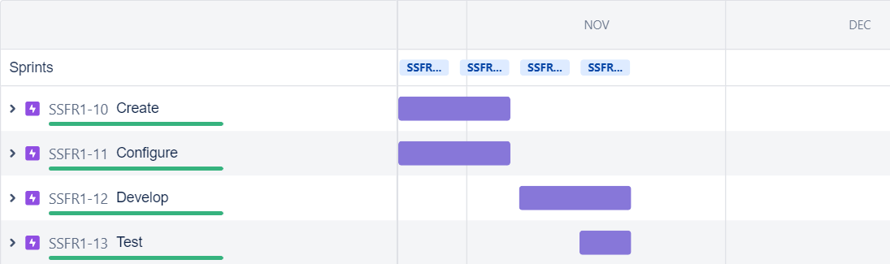

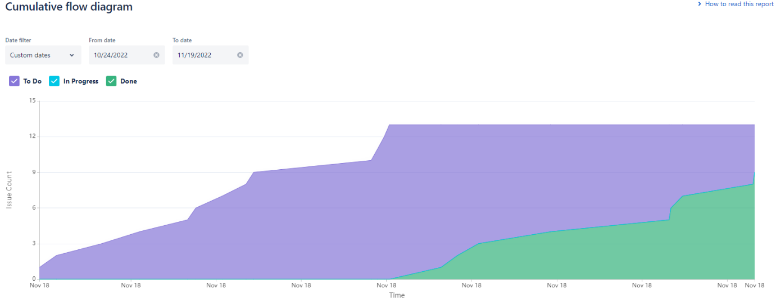

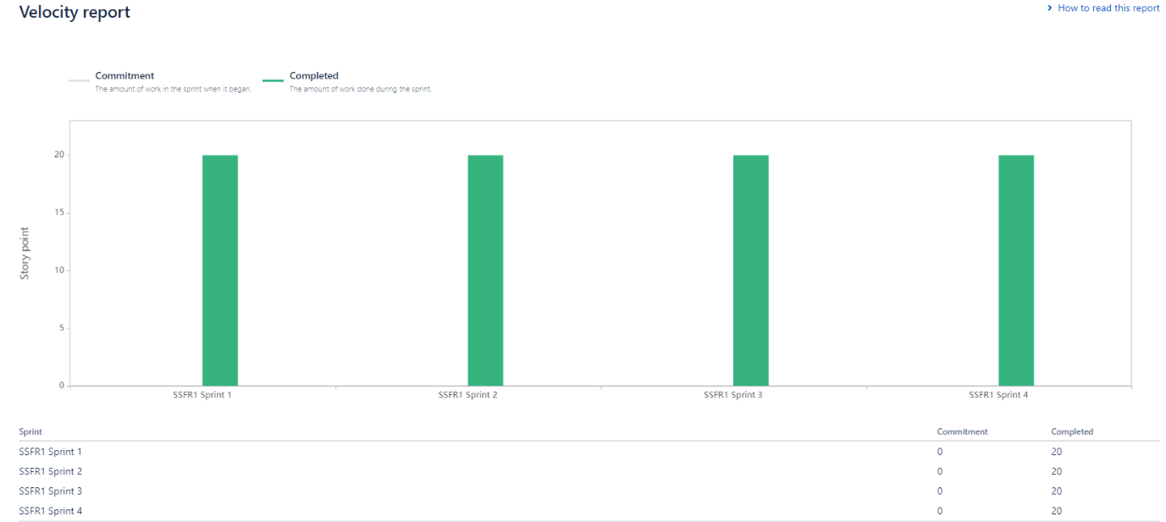

**7. CODING AND SOLUTIONING**

              7.1 Feature 1(Node Red Output

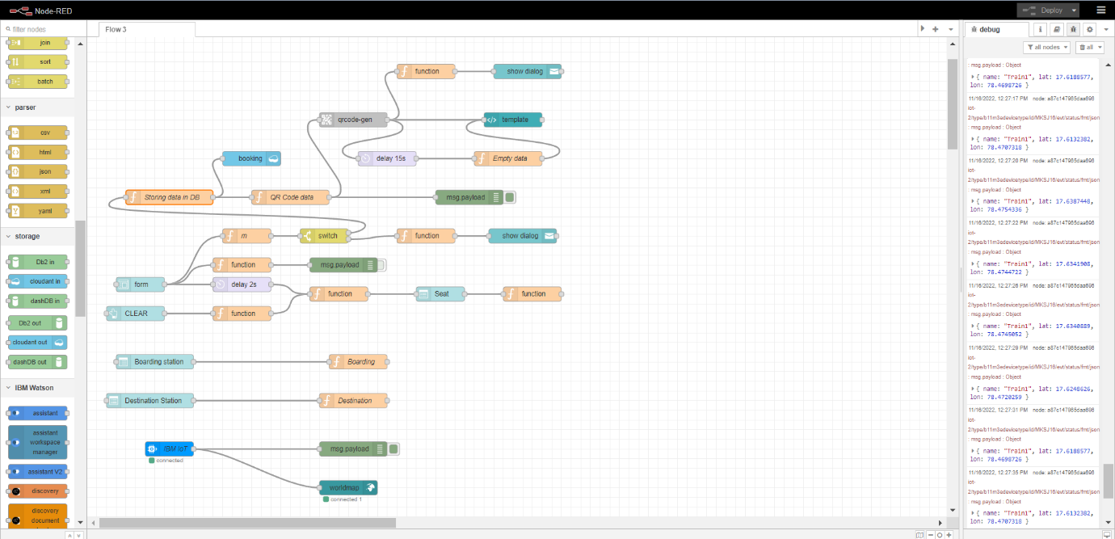

**7.2 Feature 2: (Python Output)**

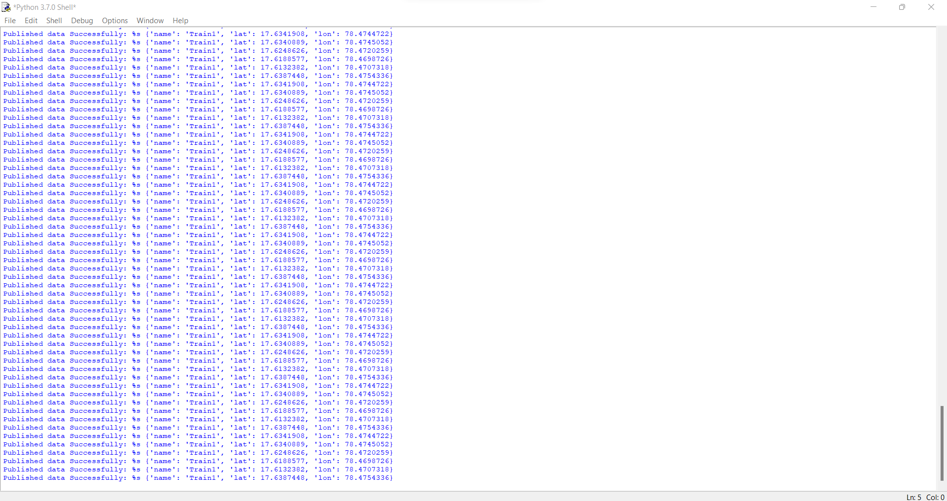

**8. TESTING** **:**

**8.1** [**Test Cases**](https://docs.google.com/spreadsheets/d/1QXSsNGGms7lcO2-4CpVd1r84Ofx48BDs/edit?usp=sharing&ouid=110984222094244942796&rtpof=true&sd=true)[**:**](https://docs.google.com/spreadsheets/d/1pcy1lCzc8DrRedD42QUKVmg7kWug-LvC/edit?usp=share_link&ouid=116741375383357107400&rtpof=true&sd=true)

**8.2** [**User Acceptance Testing**](https://docs.google.com/document/d/1RaTsXxSEccSkML8BjbpTA_ydTPazLWpp/edit?usp=sharing&ouid=110984222094244942796&rtpof=true&sd=true):

**9. RESULTS**

9.1 [Performance Metrics](https://docs.google.com/spreadsheets/d/1512GaNMm102BgbzCYKLeW6W8Qb_UKPW3/edit?usp=sharing&ouid=110984222094244942796&rtpof=true&sd=true)[:](https://docs.google.com/spreadsheets/d/1KL8QzutbtyrB8QZnpFf5syc9swHtl_2e/edit?usp=share_link&ouid=116741375383357107400&rtpof=true&sd=true)

**10. ADVANTAGES AND DISADVANTAGES**

**10.1 Advantages:**

•      No need of taking print out.

• Counter ticket has to be handled with care, but SMS on mobile is more than enough.

• You are becoming environment friendly and contributing for greener planet by ignoring printout.

• Making use of technology which urges companies (govt./private) to have more advancement in technology for better provision of services to customers.

• No need of taking out wallet and showing your ticket to TTE,just tell your name to TTE that you are passenger with a valid proof.

• While booking counter ticket you had to carry cash and while booking E- ticket you are paying through online directly from bank which makes work more easy for you.

**10.2 Disadvantages:**

                   Main disadvantage of railway reservation system is that we are not sure of getting a berth of our choice after first day of reservation in 120 day advance reservation period.This makes most of senior citizens women with infants and small children who are badly in need of lower berth at the mercy of other passengers

**11. CONCLUSION:**

                We conclude by our project is online train ticket booking is more  than better than offline booking.we can reduce the paper work and work load for the users and railway authentication

**12. Feature scope:**

                    This project has a large scope as it has the following features which helps in  making it easy to  use  understand and modify it..

         1.Automation of reservation status .

         2.No need to do paper work.

         3.To save the environment by using paper free work.

         4.To increase the accuracy and efficiency of software.

         5.Management of online  database.

         6.Management of online payment.

This web application can be readily  used by non programming personal avoiding human handled chance of error. This project is used by three types of users.

              1.Railway administrators

              2.Authorized railway reservation counters.

     Main points are:

              Simplified management of passengers

              Can be used online

              Online payment system

              Human friendly interface

**13. APPENDIX**

                       Source Code:   
 1.[Python Code Final](https://github.com/IBM-EPBL/IBM-Project-6437-1658828972/blob/main/Final%20Deliverables/SOURCE%20CODE/FINAL%20CODE.py)

                        GitHub and Project Demo Link:

1. [GitHub link](https://github.com/IBM-EPBL/IBM-Project-6437-1658828972)
2. [Project Demo Link](https://drive.google.com/file/d/1myklA4kWSC9JA43f32lNcibCjTI_vSA5/view?usp=sharing)